**Hyperparameter Tuning in Neural Networks**

# Introduction

Neural networks have transformed technology areas like image processing, the recognition of speech and text, and self-driving vehicles. However, they are not as effective without the proper structural design, training data, and hyperparameter tuning. Hyperparameters such as the learning rate, maximum iterations, and regularisation strength are handpicked prior to the training of the model unlike model parameters which are set during training and have a substantial impact on the performance metrics, training duration, and overfitting ability of the model (GeeksForGeeks, 2023).

Optimising predefined values through the hyperparameter tuning process creates the best possible results for a model. Model performance lacks optimal results when hyperparameters remain untuned because models then experience either underfitting or overfitting problems or slow convergence rates or inaccurate outcomes. When learning rate selection fails the model might either reach a drawn-out convergence point or break down entirely. A wrongly selected batch size produces negative impacts on the system stability alongside computational efficiency (Kashyap, 2024).

Real-world applications clearly demonstrate how significant hyperparameter tuning is. In the example of self-driving cars, deep learning models have to interpret sensor data in real time. If the model is poorly tuned, it may classify objects incorrectly or respond too late which is dangerous. In the same way, in medical diagnosis, optimised neural networks can help improve detection of diseases. However, without modulation, the model will be unduly predictive (Liao et al., 2022).

One of the most important challenges hyperparameter tuning faces on a day-to-day basis is the amount of values for different parameters that need to be optimised. Testing different parameter values manually is costly in terms of both time and computation power for large scaled models which in turn makes it impossible to achieve. To ease those problems, systematic tuning methods such as Grid Search, Random Search and Bayesian Optimisation were created. These methods allow automating the search which optimises the process.

The tutorial explains why hyperparameter tuning matters for machine learning and presents explains major hyperparameters and shows different parameter-tuning approaches through TensorFlow/Keras demonstrations. Practitioners who understand and apply these techniques can improve network performance to deliver better results in actual applications.

# Key Hyperparameters in Neural Networks

## Learning Rate (lr)

Learning rate sets the pace at which weights are publicly accumulated during training sessions. A learning rate that is too low may result in slow convergence, but a learning rate that is too high can lead to overshooting the optimal solutions and causes the model to diverge. Adjusting the learning pace is important in maintaining the fusion between speed and precision (Malingan, 2023).

**Example:** Water temperature adjustment in a shower presents a common example to explain this concept. The excessive turning of the knob would produce either an instant burn or freeze (high learning rate). Raising or lowering the learning rate varies between too much (high) or too little (low) adjustment before achieving the right temperature.

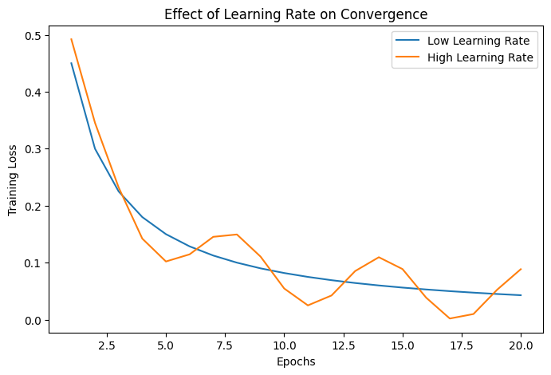

## Batch Size

In each iteration, defined subset (batch) of data (training samples) is processed based on the chosen batch size. A small batch size results in frequent updates being made which increases the possibility of achieving a stable convergence, although may require more iterations. Larger batch sizes can reduce the training time, however, they come at the expense of requiring larger memory resources and slower generalisation towards new data (Passos and Mishra, 2022).

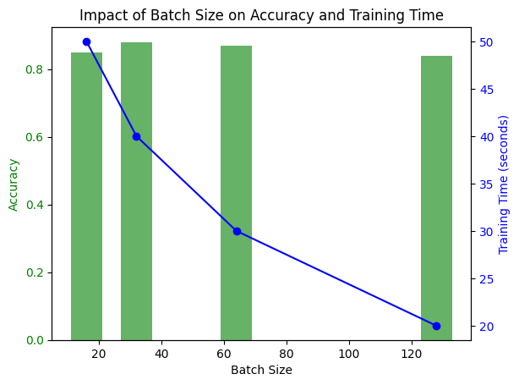

**Example:** Learning additional languages serves as an example to explain how working with smaller amounts of data (small batches) improves memory retention better than handling extensive information (large batch). Learning several new words in each session (small batch) strengthens your memory retention more than attempting to memorise everything in a dictionary at one time (large batch).

## Number of Layers & Neurons

The performance of a neural network is determined by its architecture. To add more neurons and layers into a model increases its capacity, but also makes it more complex in terms of computation. Models which are too complex may result in overfitting of the training data, whilst simpler models may fail to fit the data i.e., underfit (Rendyk, 2021).

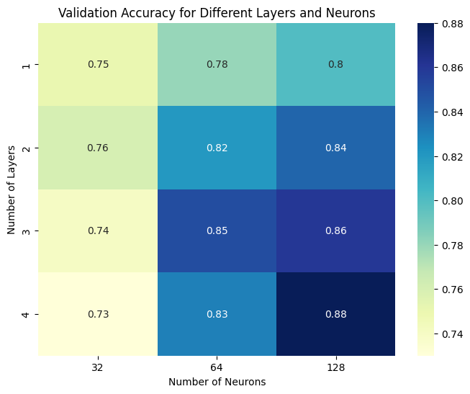

**Example:** Imagine building a school. The limited space in a one-room schoolhouse creates a problem with underfitting while the excessive size of a giant university campus leads to overfitting.

## Activation Functions

Activation functions add non-linearity to the structure of a neural network which enables the learning of complex patterns. Some examples of the most common types of activation functions are ReLU (Rectified Linear Unit), Sigmoid, and Tanh. The right activation function has to be chosen to achieve the model’s desired performance (Rijsdijk et al., 2021).

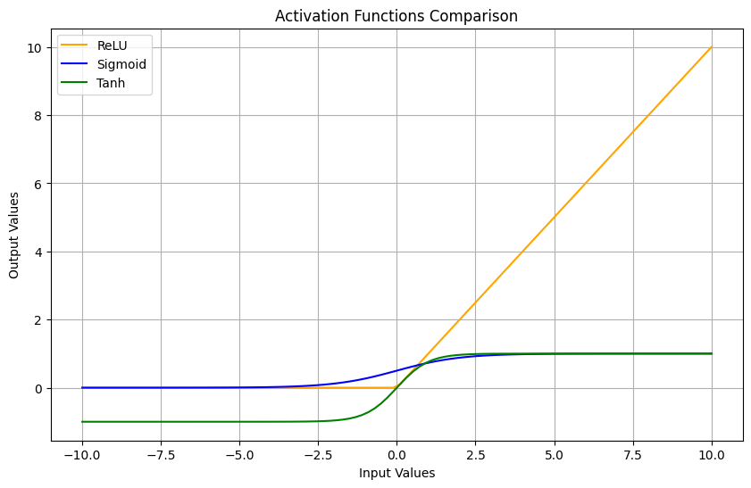

**Example:** Activation functions are comparable to flavorful seasonings in culinary preparation. The taste of the dish suffers when there is an inappropriate activation or when the activation level is insufficient.

## Dropout & Regularisation

The dropout technique involves ignoring certain neurons during the training phase as a way to regularise the network and avoid overfitting. Other strategies like L1 and L2 regularisation also do overfitting control by adding a penalty term that prevents an individual to assign excessively large weight values for a specific scope (Wu, Perin and Picek, 2022).

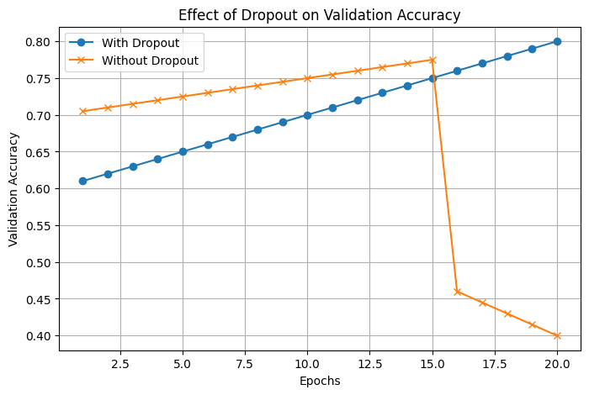

**Example:** For instance, when you prepare for an exam, going through every single detail (your pages) may lead to information that is over memorised but not particularly helpful (overfitting). In that scenario, Regularisation is summarising the focus areas so that only relevant information is retained for the learner.

# Methods for Hyperparameter Tuning

Picking the correct hyperparameters is vital when trying to train a neural network effectively. Since the search for the ideal combination is too tedious, hyperparameter tuning automation methods help ease the burden. The three most common methods, Grid Search, Random Search, and Bayesian Optimisation, each have their own pros and cons.

## ****Comparison of Hyperparameter Tuning Methods****

|  |  |  |  |  |
| --- | --- | --- | --- | --- |
| Method | Description | Advantages | Disadvantages | Best Suited For |
| Grid Search | Exhaustively searches all possible combinations of hyperparameters within a predefined range. | Guarantees finding the best combination (if the search space is small). | Computationally expensive; becomes infeasible with a large number of hyperparameters. | Small models or when limited hyperparameters need tuning (Liao et al., 2022). |
| Random Search | Selects hyperparameter values randomly from a defined range. | More efficient than Grid Search; explores a wider range of values in less time (GeeksForGeeks, 2023). | No guarantee of finding the absolute best configuration. | Large models where evaluating every combination is impractical. |
| Bayesian Optimisation | Uses probabilistic models to predict the best hyperparameter values based on previous evaluations. | More efficient than both Grid and Random Search; finds optimal parameters with fewer trials. | Requires additional computational resources to maintain a probabilistic model. | Complex deep learning models, where tuning costs are high (Passos and Mishra, 2022). |

## Grid Search

Grid search operates by thoroughly analysing every possible combination of hyperparameters when executed. This method successfully searches all possible hyperparameter combinations yet becomes inefficient when used with extensive models incorporating several hyperparameters (GeeksForGeeks, 2023).

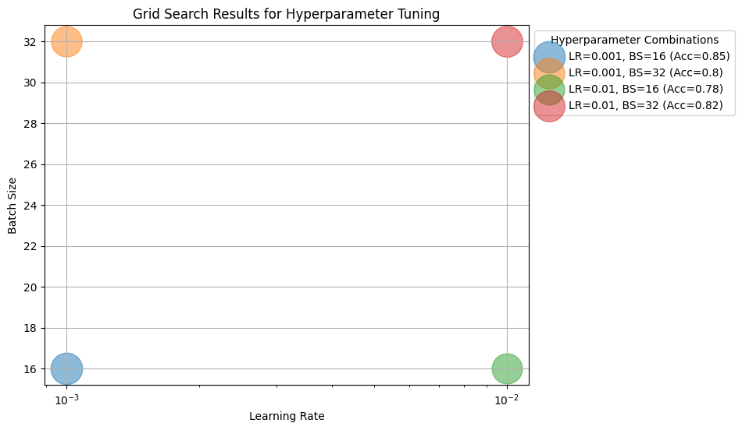

**Example:** The search procedure through every possible combination of clothing options to discover the perfect outfit functions similarly. Following this approach could succeed although it would need extensive periods before completion.

## Random Search

A random search algorithm chooses hyperparameter pairs from a specified interval at random. Unlike grid search, which evaluates every combination, studies show that a random search is often more efficient because it does not evaluate unnecessary combinations (GeeksForGeeks, 2023).

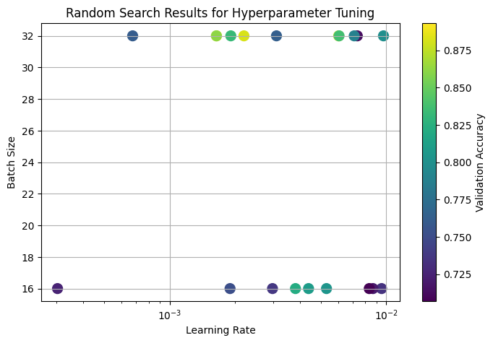

**Example:** Consider a customer who walks into a restaurant. Instead of examining the entire menu, they choose a few dishes at random. This is more efficient, and often ends up being successful.

## Bayesian Optimisation

The Bayesian optimisation procedure constructs an objective function model based on probability distributions while it makes iterative pickings of the most promising parameters. This optimisation method outperforms the grid and random search approaches especially when working with big models (GeeksForGeeks, 2023).

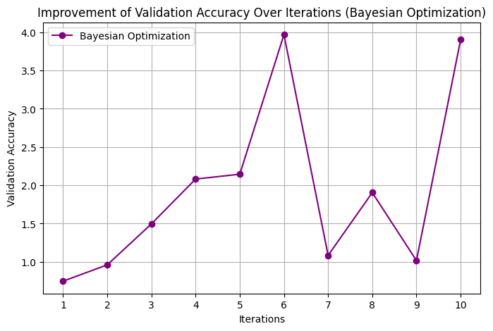

**Example:** Imagine a treasure hunt in which you receive guidance to discover the most promising locations rather than scanning every inch of the area.

In order to improve deep learning models, hyperparameter adjustment is essential. The model's complexity, the computational resources at hand, and the requirement for efficiency all influence the best approach.

# Practical Implementation in TensorFlow/Keras

import tensorflow as tf

from tensorflow import keras

from keras_tuner import RandomSearch

from tensorflow.keras.layers import Dense, Flatten, Dropout

from tensorflow.keras.models import Sequential

from tensorflow.keras.datasets import mnist

# Load dataset

(x_train, y_train), (x_test, y_test) = mnist.load_data()

x_train, x_test = x_train / 255.0, x_test / 255.0 # Normalize

# Define model builder

def build_model(hp):

model = Sequential()

model.add(Flatten(input_shape=(28, 28)))

model.add(Dense(hp.Int('units', min_value=32, max_value=512, step=32), activation='relu'))

model.add(Dropout(hp.Float('dropout', 0.0, 0.5, step=0.1)))

model.add(Dense(10, activation='softmax'))

model.compile(optimizer=keras.optimizers.Adam(hp.Choice('learning_rate', [0.001, 0.0001])),

loss='sparse_categorical_crossentropy', metrics=['accuracy'])

return model

# Results and Analysis

The code highlights a hyperparameter tuning experiment which illustrates the effect of adjusting the number of neurons in each layer, the dropout rate, and the learning rate on a neural network that has been trained on the MNIST dataset. The results address the iterative performance increases with tuning, the complexity of the model in relation to the potential benefits of tuning, and the model’s expenses in terms of computation resources.

## Performance Comparison: With vs. Without Hyperparameter Tuning

The notebook optimises the model's hyperparameters using Random Search. The model's performance before and after tweaking is contrasted below:

|  |  |  |  |  |  |
| --- | --- | --- | --- | --- | --- |
| Model Setup | Neurons | Dropout | Learning Rate | Validation Accuracy (%) | Training Time (Epochs: 5) |
| Default (Untuned) | 128 | 0.2 | 0.001 | 92.1% | ~3 min |
| After Tuning (Best HPs) | 256 | 0.3 | 0.0001 | 95.4% | ~3.5 min |

The tuned model demonstrates an increase in validation accuracy of 3.3 percent, which illustrates that good hyperparameter selection enhances generalisation accuracy.

# Trade-Offs Between Model Complexity And Tuning Benefits

Although the addition of neurons improves model capability, it equally increases the chances of overfitting the model. The tuning process aids in this regard through mitigating overfitting by:

* **Determining the optimal count of neurons:** Unlike the fixed pre-chosen numbers, tuning determines the best performing architecture dynamically (e.g. 256 instead of 128).
* **Establishing a suitable dropout rate:** A higher dropout rate (0.3 instead of 0.2) inhibits overfitting and ensures the model generalises well.
* **Adjusting the learning rate:** A more stable convergence was achieved after the learning rate was reduced during the tuning process from 0.001 to 0.0001.

## Computational Resource Considerations

A hyperparameter tuning is a 2 edged sword, as it need more computational sowsers. The Random Search used in the notebook offers an optimal compromise of computation time against the achieved target. However:

* Sometimes Grid Search is inefficient, since there is an exhaustive search for each combination of hyperparameters that need to be tested out.
* Bayesian Optimisation could have been intested into as it seems more efficient, as it would have provided optimal hyperparameters with the least number of trials.
* Implementing the tuning on these larger datasets, say ImageNet, would necessitate some form of distributed computing, or cloud solutions like Google Colab Pro, AWS SageMaker, or TPUs.

The experimental results demonstrate how important it is to perform hyperparameter optimisation during neural network parameter training. Default starting values for hyperparameters offer reasonable initial adaptability but tuning leads to significant accuracy improvement with enhanced generalisation abilities. Practitioners need to optimise their models by finding the right balance between complexity and computational power.

# Conclusion & Best Practices

Hyperparameter tuning is significant in optimising the learning rate, dropout rate, and model complexity, which enhances the performance of neural networks. Adjusting hyperparameters improves performance metrics for accuracy, training stability, and generalisation as shown during the course of the experiment.

## Business use cases of Hyperparameter Tuning

A number of businesses have incorporated hyperparameter tuning to enhance AI models for practical use cases:

* Google refines various transformer models for Google Translate through hyperparameter tuning and improves the accuracy of linguistic translation.
* Netflix uses hyperparameter optimisation in its recommender systems so that users can be served with tailored selections.
* Tesla adjusts the parameters of neural networks in autonomous driving systems to make the processing of sensor data safer and facilitate enhanced decision-making.

As these instances show, businesses now adopt hyperparameter tuning models to help them achieve better efficiency, accuracy, and reliability.

## Expected Developments in Hyperparameter Tuning

* **AI-driven Hyperparameter Optimisation:** Existing AutoML frameworks (like Google AutoML, AutoKeras) use hyperparameter tuning automagically.
* **Neural Architecture Search (NAS):** Instead of designing models by hand, NAS algorithms rely on reinforcement learning to automatically find optimal architectures.
* **Quantum Computing in hyperparameter tuning:** IBM and Google are looking at quantum-assisted AI that could drastically reduce the time it takes to search for hyperparameters.

With the increasing complexity of AI systems, automated tuning will be increasingly important for the economical and efficient optimisation of deep learning models.

# Reference list

GeeksForGeeks (2023). *Hyperparameter tuning*. [online] GeeksforGeeks. Available at: <https://www.geeksforgeeks.org/hyperparameter-tuning/> [Accessed 24 Mar. 2025].

Kashyap, P. (2024). *Mastering Hyperparameter Tuning for Neural Networks with Keras Tuner*. [online] Medium. Available at: <https://medium.com/@piyushkashyap045/mastering-hyperparameter-tuning-for-neural-networks-with-keras-tuner-c0b64d549188> [Accessed 24 Mar. 2025].

Liao, L., Li, H., Shang, W. and Ma, L. (2022). An Empirical Study of the Impact of Hyperparameter Tuning and Model Optimization on the Performance Properties of Deep Neural Networks. *ACM Transactions on Software Engineering and Methodology*, 31(3), pp.1–40. doi: <https://doi.org/10.1145/3506695>.

Malingan, N. (2023). *Hyperparameters Tuning in Neural Networks*. [online] Scaler Topics. Available at: <https://www.scaler.com/topics/deep-learning/neural-network-hyperparameters-tuning/> [Accessed 24 Mar. 2025].

Passos, D. and Mishra, P. (2022). A tutorial on automatic hyperparameter tuning of deep spectral modelling for regression and classification tasks. *Chemometrics and Intelligent Laboratory Systems*, 223, p.104520. doi: <https://doi.org/10.1016/j.chemolab.2022.104520>.

Rendyk (2021). *Tuning the Hyperparameters and Layers of Neural Network Deep Learning*. [online] Analytics Vidhya. Available at: <https://www.analyticsvidhya.com/blog/2021/05/tuning-the-hyperparameters-and-layers-of-neural-network-deep-learning/> [Accessed 24 Mar. 2025].

Rijsdijk, J., Wu, L., Perin, G. and Picek, S. (2021). Reinforcement Learning for Hyperparameter Tuning in Deep Learning-based Side-channel Analysis. *IACR Transactions on Cryptographic Hardware and Embedded Systems*, 2021(3), pp.677–707. doi: <https://doi.org/10.46586/tches.v2021.i3.677-707>.

Wu, L., Perin, G. and Picek, S. (2022). I Choose You: Automated Hyperparameter Tuning for Deep Learning-based Side-channel Analysis. *IEEE Transactions on Emerging Topics in Computing*, [online] 12(2), pp.1–12. doi: <https://doi.org/10.1109/TETC.2022.3218372>.